Nominee:
Name: Click or tap here to enter text.
Address: Click or tap here to enter text.
Phone: Click or tap here to enter text. Mobile: Click or tap here to enter text.
Date of Birth/Age: Click or tap here to enter text. Email: Click or tap here to enter text.

Nominated by:
Name: Click or tap here to enter text.
Organisation: Click or tap here to enter text.
Address: Click or tap here to enter text.
Phone: Click or tap here to enter text. Mobile: Click or tap here to enter text.
Email: Click or tap here to enter text.

Referee: (other persons that may be contacted for further information about nominee)
Name: Click or tap here to enter text.
Organisation: Click or tap here to enter text.
Address: Click or tap here to enter text.
Phone: Click or tap here to enter text. Mobile: Click or tap here to enter text.
Email: Click or tap here to enter text.

Close of Nominations:
Nomination forms must be received by 4:15pm close of business 29th October 2021 to the Shire Administration Office via one of the following methods.
Email: mail@brookton.wa.gov.au
Hand Deliver: 14 White Street, Brookton WA 6306
Post: PO Box 42, Brookton WA 6306

Please write below a short description (500 words or less)

the scope of impact the voluntary act it had on the Community.

Click or tap here to enter text.

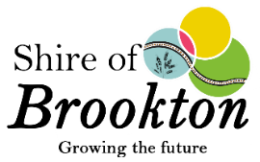
Voluntary Act Award – Criteria & Eligibility

*Nominations are based on events held throughout the 2021 year, and the awards will be presented on Australia Day 2022.

- The nature of the individual voluntary act
- An act cannot receive a second award in this category
- The scope of impact the act has had on the local government area including the achievements and reasons for the nomination must be explained

