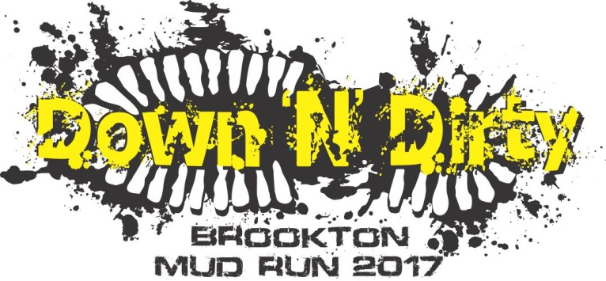

TERMS AND CONDITIONS OF ENTRY
- The Brookton Mud Run is an extreme sport event being held at the Brookton Country Club on Saturday 8 July 2017.
- The Brookton Mud Run is organised by the Shire of Brookton & a volunteer organising committee from the Brookton Community.
- By registering to participate in the Brookton Mud Run I, the undersigned, agree to be bound by these terms of entry.
- The Brookton Mud Run event policy (“the Event Policy”), which can be viewed at www.brookton.wa.gov.au forms part of these terms & conditions.
- Where there is an inconsistency between the terms and conditions and the Event Policy the terms and conditions prevail.
- I agree to comply with all of the Brookton Mud Run rules specified in the Event Policy and I agree to comply with all directions given to me by medical/ambulance officers, Shire of Brookton employees or representatives and any officials or volunteers representing the Shire of Brookton.
- I agree to participate safely and responsibly while participating in the Brookton Mud Run and consider the safety of other participants, officials, volunteers & spectators.
- I understand the demanding physical nature of this event.
- I am not aware of any medical condition or impairment that will be detrimental to my health if I participate. In the event I become aware of any medical condition or impairment, or become sick or injured prior to the event, I will withdraw from the event.
- I acknowledge that participating may involve risk of injury or even death from various causes including over-exertion, dehydration and accidents with other participants, or spectators.
- I acknowledge that I participate in this event at my own risk and accept full responsibility.
- I consent to receive medical treatment on the day of the mud run/walk in the event of illness or injury. I authorise the organisers in the event of an accident or illness to obtain all necessary emergency medical, hospital and ambulance assistance and I agree to meet any expenses incurred, if applicable.
- Should the event be cancelled for any reason whatsoever, I understand that no liability of any kind will attach to any person, corporation or body involved or otherwise engaged in promoting or staging of the event. I acknowledge that participation in the Brookton Mud Run is:
  - A Dangerous Activity
  - Involves inherent risks of injury which cannot be completely eliminated, and
  - Involves the real risk of serious injury and even death from matters, including , but not limited to, activities such as climbing, rope swinging, running on uneven ground, crawling through mud, other unspecified surprise activities during the Brookton Mud Run and collisions or accidents with natural or man-made hazards and obstacles and other participants in the Brookton Mud Run.
- I accept all risk and release the event organiser, affiliates, employees, members, supporters, promoters, volunteers and any person or body, directly or indirectly associated with the event, from all claims, demands and proceedings arising out of or connected with my participation in this event and indemnify them against all liability for all injury, loss or damage arising out of, or connected with, my participation in this event. I give permission for the use of my name, voice or picture in any broadcast, telecast, advertising promotion or other account of this event. I give the Shire of Brookton permission to publish my photo/recording, and my name, for the above purpose and store these in Council’s media library for use in print and online publications promoting Council services. If you are under the age of 18 as at the date registration for the event:
- You have obtained the consent of a legal guardian to participate in the Brookton Mud Run
- Your legal guardian must complete the consent clause below
- Your legal guardian must be present at the Brookton Mud Run and is responsible for you at all times at the event
- You confirm that you will be over the age of 12 on event day being 8 July 2017
- The entry fee is non-refundable in any circumstance

I have read and agree to abide by the terms and conditions of this event as stated in the waiver above.

Name: Signature: Date:

Parent/Guardian Consent

I confirm I have given consent for ___________________________to participate in the Brookton Mud Run. I have read the terms and conditions of this event as stated in the waiver above and confirm that on the day of the Brookton Mud Run _______________________will be over 12 years of age.

Name: Signature: Date:

Relationship to minor:

