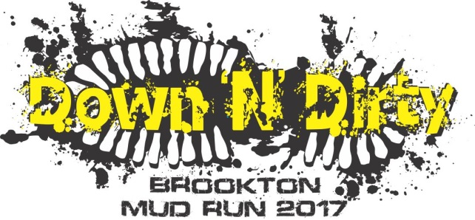
BROOKTON MUD RUN RULES
- The Brookton Mud Run is organised as a participation event it is not a race and it is not being timed.
- While we encourage participants to have a go, you do not have to complete any obstacle you don’t feel you can just continue down the track to the next obstacle.
- Sportsmanship & courtesy is encouraged by all participants particularly the helping of other participants who may require a helping hand.
- As part of the event we would love to see you &/or your team dress up for the occasion however any outfit deemed dangerous to you or fellow participants will not be allowed. The organising committee and/or starting Marshall reserve the right to ask any participant who’s costume they believe could be dangerous to change prior to partaking in the event (Long dress trains, swimming flippers, hand held items, items that tie around the neck).
- Participants must wear suitable footwear which is adequate for gripping surfaces and protecting feet (must be flat soled shoes).
- All jewellery is to be removed prior to participation & use of electrical devices including but not limited to mobile telephones, mp3 players, mobile disc players & cameras are prohibited to be carried by any participant on the course.
- Marshalls will be stationed at each obstacle and other areas around the course if they witness any offensive or destructive behaviour the participant will be immediately disqualified from the event and escorted back to the marshalling area.
- Please keep to the tracks so that you do not disturb or damage surrounding bush areas, all obstacles have been built so that the dirt track leads you to them. Anyone who deviates from the course on purpose will be disqualified and escorted back to the marshalling area.
- No running on or crossing of the golf fairways is permitted please stay to the marked pathways at all times, if in doubt check with a course Marshall.
- The Brookton Mud Run is about having fun so feel free to laugh plenty and smile for the photographers who will be moving around the course.
- The Brookton Mud Run is held at the Brookton Country Club please show respect towards these facilities so we can continue to host our event here.

